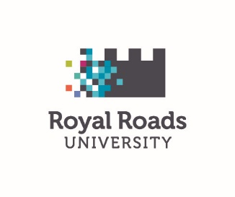

“Everyone Counts” – RRU’s Equity, Diversity and Inclusion survey – May 2019

Thank you for participating in the first Everyone Counts EDI survey at Royal Roads! Below are the results of the survey, aggregated to remove any identifying data.
The on-line survey was distributed to all current Royal Roads University employees on May 9, 2019. A hard-copy version was also made available to capture employees who preferred to respond in this manner. The analysis of the survey is as follows:

Response and completion rates:
- Distributed to 519 employees which attracted 301 responses representing a 58% response rate resulting in 298 surveys being fully completed for a completion rate of 99%.
Demographic representation of respondents:
- Only one demographic question was asked of the respondent. The question was ‘select the group that represents your role at RRU’. The highest percentage response was from the Non-unionized Grades 3&4 (Professional/Technical staff) at a response rate of 35.57% (106 count).
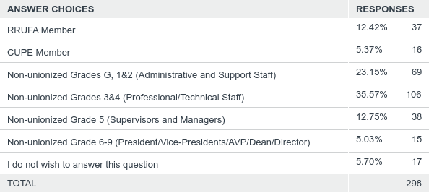
Representation of the Four Designated Groups (FDGs) federally regulated within the Employment Equity Act and our two additional areas of gender diversity and sexual orientation:
Group | Response rate  (Percentage and individual count noted - red = highest response)
 | Yes |  | No |  | Do not wish to answer
Indigenous peoples who identify as First Nations, First Peoples, Inuit, Inuk, and Métis people of North America | 3.02%  9 responses |  | 94.30%  281 responses |  | 2.68%  8 responses
Visible minorities are people (other than Indigenous peoples) who self-identify as non-white in colour and are generally defined as a person of colour, regardless of their place of birth or citizenship. | 16.44%  49 responses |  | 80.87%  241 responses |  | 2.68%  8 responses
Persons with disabilities, means persons who have long-term or recurring physical, mental, psychiatric, sensory or learning impairments. | 11.74%  35 responses |  | 86.24%  257 responses |  | 2.01%  6 responses
Gender diversity, a person who self identifies as: Transgender, Transsexual, Two-Spirit, Gender Non-conforming, Gender Variant, Non-Binary, Agender, or who otherwise does not identify with the gender assigned at to them at birth. | 2.35%  7 responses |  | 95.30%  284 responses |  | 2.35%  7 responses
Sexual orientation representation, a person who self identifies as: Lesbian, Gay, Bisexual, Queer or who otherwise does not identify as heterosexual. | 11.41%  34 responses |  | 83.89%  250 responses |  | 4.70%  14 responses
 | Woman | Man |  | Other |  | Do not wish to answer
Representation of gender identity within the RRU community. | 72.15%  215 responses | 23.83%  71 responses |  | < 5 responses |  | 2.68%  8 responses

What is this census telling us?
- Of those who responded, 58% of RRU’s employee demographic at the time of the survey, the majority identified as:
  - Women
  - Without a disability
  - Non-Indigenous
  - Not a Visible Minority
  - Heterosexual
  - Cisgender

Comments following survey questions
Respondents were invited to provide comments at the end of each question and at the end of the survey to provide any additional general comments regarding the EDI initiative at RRU.
Question | Number of comments | Percentage of total response to survey
Q3 – Indigenous | 7 | 2.34%
Q4 – Visible minorities | 3 | 1.00%
Q5 – Persons with Disabilities | 7 | 2.34%
Q6 – Representation of women at RRU | 2 | 0.67%
Q7 – Gender Diversity representation | 3 | 1.00%
Q8 – Sexual Orientation representation | 8 | 2.68%
Q9 – General comments | 32 | 10.7%

Common themes
A reflexive thematic analysis was used in analyzing the comments made in the survey. The common themes are presented in order of high-low frequency of appearance in the analysis as follows:
Support
The Royal Roads community expressed overwhelming support for the purpose of the survey and the work being done to ensure that, at Royal Roads, Everyone Counts!
Concerns
Commonly expressed concerns around the purpose of the survey included future employment, the potential of the work to cause harm, and concerns regarding quotas in the workplace.
Identification
Some respondents were unclear on the criteria for identifying ethnic backgrounds, and particularly what the definitions were for Indigenous peoples, visible minorities, and what is included or excluded in the definition of disability.
Who is missing?
Religion and spirituality, people with criminal records, single parents, cultural identities, first languages, immigrants, and temporary vs. permanent staff were all raised as potential gaps in the survey.
Community needs
This survey identified a need for an environment that recognizes the work performed and to provide fair treatment for both union and non-union members equally. There was a demonstrated need for Royal Roads to recognize those impacted by disability and provide stronger support for those individuals.
Next time
For the next Everyone Counts survey, respondents are hoping for a more data-driven approach to the work as well as more freedom to respond to overarching questions. There is an identified need for increased transparency around the project.

What are our next steps?
Human Resources, specifically the EDI project team led by Lisa Robinson, will translate the survey findings and analysis into detailed action items to present to the Human Resources Governance Committee. Two key priorities are: to ensure we increase our transparency on EDI activities; and to ensure there aren’t any unintended negative consequences resulting from this important work (i.e. employees concerned for their employment with RRU).

Resources
The Equity Diversity and Inclusion page on the Human Resources website will reflect all current EDI activity at RRU related to our employees. External partnerships have been established with the Canadian Centre for Diversity and Inclusion and the Pride at Work Canada organization. Both offer a wealth of resources to RRU employees.

Reference list
Braun, V. & Clarke, V. (2006). Using thematic analysis in psychology, Qualitative Research in Psychology, 3:2, 77-101. Retrieved from https://www.tandfonline.com/doi/pdf/10.1191/1478088706qp063oa?needAccess=true
Vaismoradi, M., Turunen, H., & Bondas, T. (2013). Qualitative descriptive study. Nursing Health Science, 15: 398-405. Retrieved from https://onlinelibrary.wiley.com/doi/epdf/10.1111/nhs.12048

